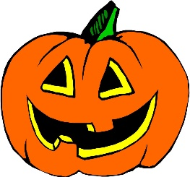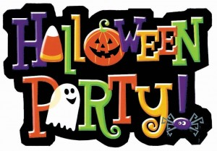**Week of October 29, 2018**

SPECIALS

**Monday**- Music

**Tuesday**- Library

**Wednesday**- Gym

**Thursday**- Art

**Friday**- NO SCHOOL

****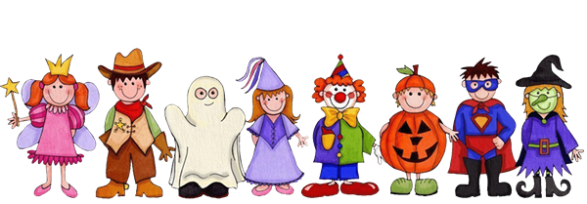Mrs. Cochran

A PEEK AT THE WEEK! 

Daily- calendar (days of week, months, date, shapes, number sentences, money, time, number in different ways), morning activity, morning message

Go Math Chapter 2- Numbers 6-10

Reading- Stories: *I Am Enough, The Roll Away Pumpkin, Smelly Socks*

WIN- What I Need- Reading- focus- words in a sentence, rhyming words, beginning sounds, alphabet work with focus letters Mm, Nn, Ll, Kk

Wednesday, October 31- Halloween party and parade- Parade will be first then the party. Party will end at 11:30. Please remember no weapons or blood.

Friday, November 2- NO SCHOOL FOR STUDENTS-

**Reminders**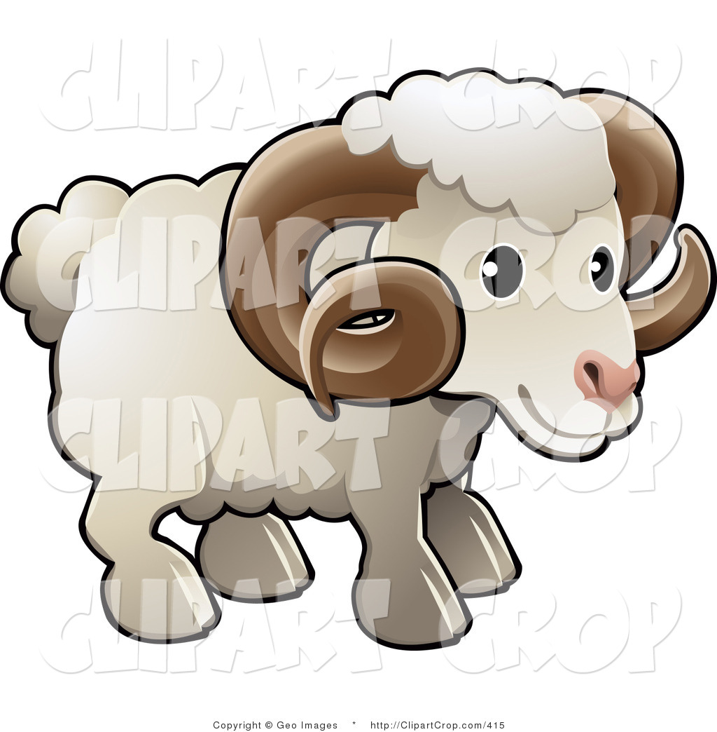

**Please contact me at 724-224-5880 ext 202. If you cannot reach me in the classroom, and it is an emergency, please contact the office and have them connect you to me. You can also email me at** [**mecochran@goldenrams.com**](mailto:mecochran@goldenrams.com) **I check my emails often throughout the day so email is a great way to reach me.**

**Please remember to send in five snacks for your child in their snack bag. If you can’t send a snack please let me know.**

**Please remember to send your child’s folder daily along with their backpack. I do not send papers home without a folder. This is how papers get lost or misplaced. Also, please dress weather appropriate. We go outside if it is above 35. Make sure your child has a coat. TY ☺**

**Centers**

**Language Centers- WIN-**

* **alphabet fall trees**
* **Predecodable Stories w/Mrs. Cochran**
* **Beginning sounds pumpkin match**
* **Rhyming fun**

**Math- -**

* **Shapely Scarecrow**
* **Roll and count sets of numbers**
* **Fall roll and record**
* **Work with Mrs. Cochran**